№ | Mistake |  | Comments
1 | 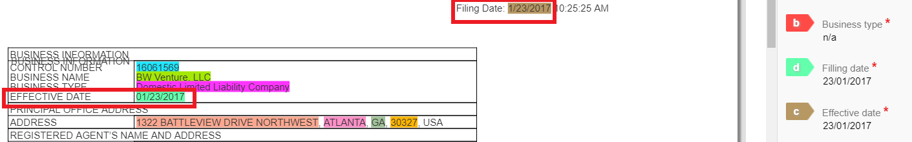 |  | The filing date and effective date here are equal. But nevertheless, they should be tagged in the corresponding places, not vice versa.
2 |  |  | Zip code is missing in the answers while it is present in the document.
3 |  |  | For Secretary of State answer should be just the name of the state, you do not need words “State of”
4 |  |  | The trademark name should be tagged together with inverted commas and dots, because it’s a part of name.
5 |  |  | The legal ending is also part of trademark name and should be always included.
6 |  |  | The comma in the end of the street address should not be tagged.
Qualification mistakes

